ANALYSIS OF A LOW-CAMBERED AEROFOIL

MODULE: FLUIDS AND AERODYNAMICS

MODULE CODE: 5ENT1128-0901

MODULE LEADER: BEN STACEY

SUBMITTED BY STUDENT ID: 20011451

SUMMARY

Developing a new wing design demands a comprehensive analysis of the aerofoil(s) aerodynamics characteristics to be used with a precise emphasis on the coefficient of lift (C_{l}). This report highlights the process conducted to collect wind tunnel measurements and derive coefficient of lift results from coefficient of pressure (C_{p}). The results are later used to calculate the coefficient of lift values for an unknown aerofoil and are presented in coefficient of pressure against chord and coefficient of lift against alpha plots. Some of the concept of lift theories are briefly highlighted and justified. Various sources of error that might have occurred whilst collecting data from the wind tunnel and some of the precautions to take are also highlighted.

TABLE OF CONTENTS

1.INTRODUCTION Page 4

1.1 INTRODUCTION Page 4
1.2 THEORETICAL BACKGROUND Page 5

2.METHODOLOGY Page 6

2.1 DATA COLLECTION & APPARATUS Page 6
2.2 ERRORS & PRECAUTIONS Page 7

3.CALCULATIONS AND RESULTS Page 8

4.GRAPHS Page 13

4.1 COEFFICIENT OF PRESSURE PLOTS Page 13
4.2 COEFFICIENT OF LIFT PLOTS Page 14

5.DISCUSSION OF RESULTS

5.1 ASSUMPTIONS AND JUSTIFICATION DISCUSSION
5.2 BOUNDARY LAYER FORMED DISCUSSION
5.3 DISCUSSION ON GRAPH
5.4 DISCUSSION ON UNCERTANITY AND ERROR

6.CONCLUSION

7.REFERENCES

8.APPENDIX

1.INTRODUCTION

1.1Introduction
In this study, an experiment on a wind tunnel was conducted to collect pressure data across an aerofoil at various angles of attack. The resulting coefficient of pressure (C_{P}) data was utilized to calculate coefficient of lift (C_{L}) values, which were then plotted against angles of attack, producing C_{L} vs. alpha plots. Aiming to derive crucial aerodynamic data to inform the selection of optimal flight regimes for the aerofoil design, the findings of this study provide valuable insights into the aerofoil's performance, enabling informed decisions in the lab experiment process.

The experiment was conducted on an AF1300 Subsonic Wind Tunnel located in E131 of College Lane Campus at The University of Hertfordshire (University of Hertfordshire, 2023). The wind tunnel is a low-speed wind tunnel, and an example of the wind-tunnel is shown in Figure1.1 below.

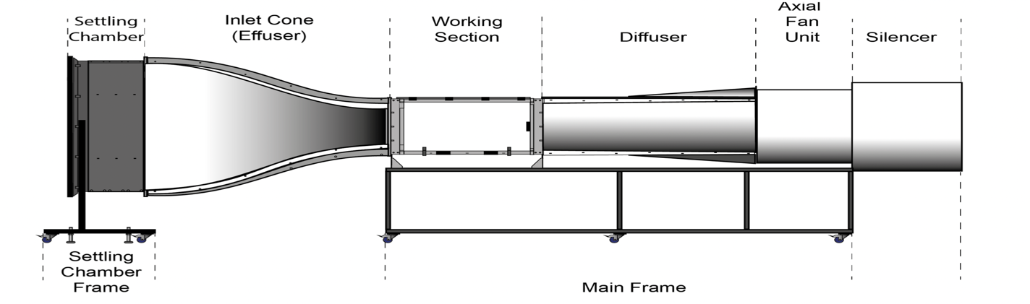
Figure 1.1: AF1300 Wind Tunnel

The specifications of the wind tunnel are shown in Table 1.1 below.

Table 1.1: Specification Table (University of Hertfordshire, 2023)

Item Specification

Working Section 305mm x 305mm x 600mm

Overall Tunnel 1056mm x 1065mm x 3700mm

Contraction Ratio 12:1

The aerofoil used for the experiment was unknown and required further investigation. Presented without any flaps or control surfaces, it contains 20 tappings placed at intervals, each connected to a digital pressure transducer via tubing. The tappings is what allows us to plot C_{p} against chord position graphs for both upper and lower surface. The aerofoil has a nett weight of 800g and a chord length of 150mm (University of Hertfordshire, 2023).

SRN:20011451

1.2Theoretical Background

Wind Tunnels
Wind tunnels are like large tubes with air moving inside. An object is placed stationary in the tube and the air is blown around the object. This enables one to study and understand the interaction between the moving air and the object. In this report, the object is an aerofoil inside a low-speed wind tunnel. Air enters the tunnel via an aerodynamically built effuser or inlet, which linearly accelerates the air. It then goes through a grill as it reaches the working area where the aerofoil is and goes to the axial fan through the diffuser only to exit the wind tunnel.

Aerofoil
An Aerofoil is a cross-sectional shape designed and characterised by its curvature. It is able to generate lift when it interacts with a fluid such as air. Aerodynamic forces and moments due to pressure and shear distribution on the surface of the aerofoil result in lift, drag, C_{L} and C_{P} among others hence mathematically,

$C_{L}=L/{q_{∞}S}$ $C_{D}=D/{q_{∞}S}$

Where C_{L} = Coefficient of Lift Where C_{D}= Coefficient of Drag
L= Lift D= Drag
$q_{∞}=$ Dynamic Pressure $q_{∞}=$ Dynamic Pressure
S= Reference Area S = Reference Area (Anderson John, 2016)

One or more aerofoils typically make up a wing in an aeroplane. Figure 1.2 below shows an example of an aerofoil.

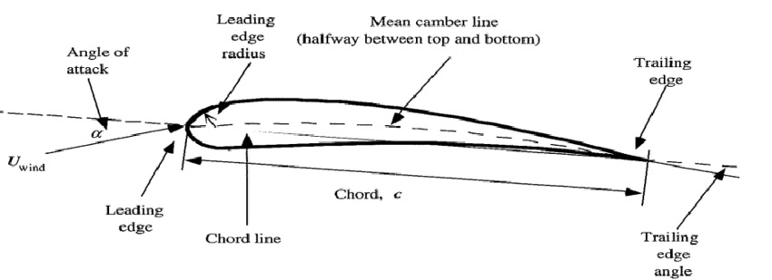
Figure 1.2: An Aerofoil (Ajay Veludurthi, 2020)

Due to pressure and shear distribution on the surface of the aerofoil, a resultant force (R) and momentum (M) are produced. The resultant force (R) can be spilt into Lift (L) and Drag (D) and the Momentum (M) to Normal Force (N) and Axial Force (N) as shown in figure 1.3. Since the Angle of Attack $∝$ is defined as the $∝$ between V$∞$ and c (chord) or can be the angle between L and D or N and A, then:

$∝=V_{∞}between C$ $L=Ncos∝-Asin∝$

Or $D=Nsin∝+Acos∝$

$∝=∝L between D.$

Or
$$∝=∝between N and A$$
SRN:20011451
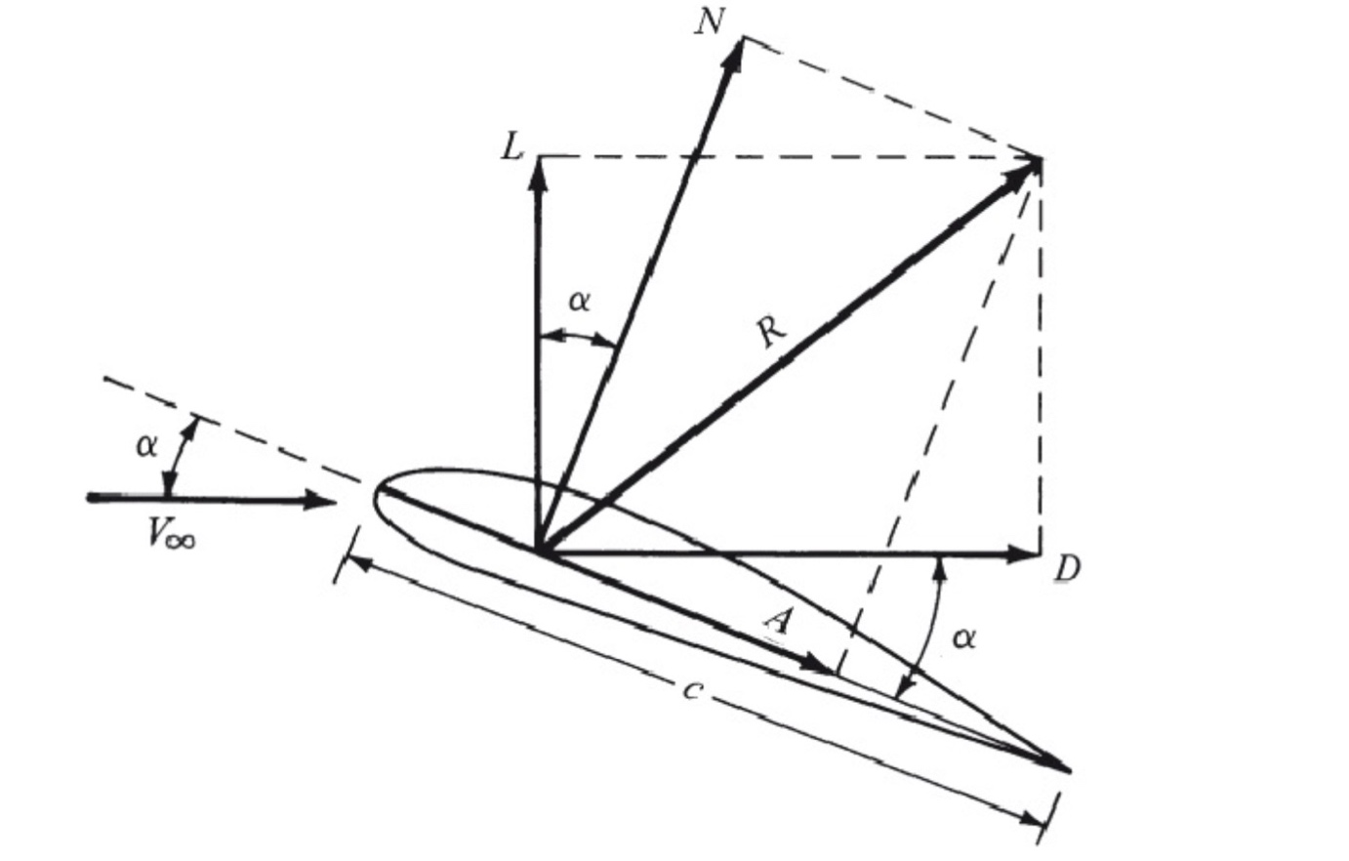

Figure 1.3: Forces acting on an Aerofoil.
The information above was sourced from (Anderson John, Fundamentals of Aerodynamics, 2016). It is important to note that the above formulas are used for a three-dimensional body. For a two dimensional, quantities of immediate use are:

1.Pressure Coefficient 3. Skin friction coefficient

${ C}_{p}=\frac{p-p_{∞}}{q_{∞}}$ $c_{f}=\frac{τ}{q_{∞}}$

2.Coefficient of Lift
$$C_{l}=\frac{l^{1}}{q_{∞}c}$$

The lift and drag coefficients can be obtained from:

$$c_{l}=c_{n}cos∝-c_{a}sin∝$$

$$c_{d}=c_{n}cos∝+c_{a}sin∝$$
Lift and Theories
A lift is a force that holds an aircraft in the air. Many theories describe how lift is generated on an aerofoil. Bernoulli’s position is that lift is generated by the pressure difference across the wing and Newton's position is that lift is the reaction force on a body caused by deflecting a flow of gas. (Nancy Hall, 2022). The Kutta-Joukowski Theorem states that for a two-dimensional object, the circulation around the body has a directly proportional relation to lift per unit span (John D. Anderson, 2001). As the flow over an aerofoil develops, the stagnation point located on the upper surface finds its way to the trailing edge. This happens as nature chooses, the value of circulation, the Kutta Condition. This addition of circulation to move the stagnation point creates a pressure difference between the upper and lower surfaces, hence generating Lift (John D. Anderson, 2001).

SRN:20011451
2.METHODOLOGY

2.1 Data Collection and Apparatus
Flow velocity had to be determined to collect the pressure tappings. This was done using the dynamic pressure given in mmH₂O displayed by the manometer (Figure 1.3) on the control console and an equation was derived. All were sourced from (University of Hertfordshire, 2023).

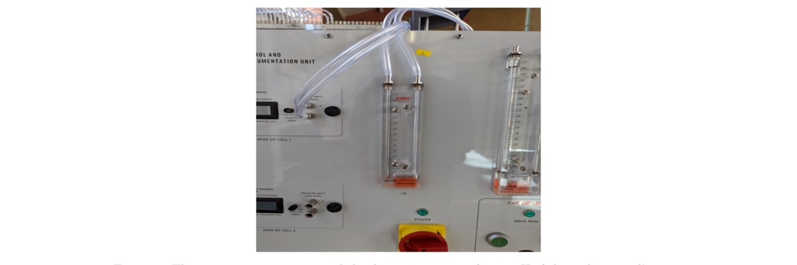
Figure 1.4 A Manometer
(University of Hertfordshire, 2023)

$ν=\sqrt{{2q}/ρ}$
Where q= Dynamic Pressure
$ρ$= Atmospheric Density

The atmospheric density is a function of various atmospheric conditions shown by the equation below sourced from (University of Hertfordshire, 2023).

$ρ=\frac{p_{o}}{1+γt} \frac{P_{a}}{P_{∞}}$

Where $ρ=Atmospheric Denisity$ $P_{a}=Atmospheric Pressure$
$p_{o}=1.276{kgm}^{-3}$ $t=Temperature in C$
$P_{∞}={10}^{5}Pa$
$γ=0.03661$

It was then necessary to collect the atmospheric temperature and pressure measurements which are needed to accurately determine the properties of the air in the tunnel. A modern method was used to do so by using a calibrated and standard barometer as shown in figure 1.4. (University of Hertfordshire, 2023)

Figure 1.5 Digital Barometer (University of Hertfordshire, 2023)
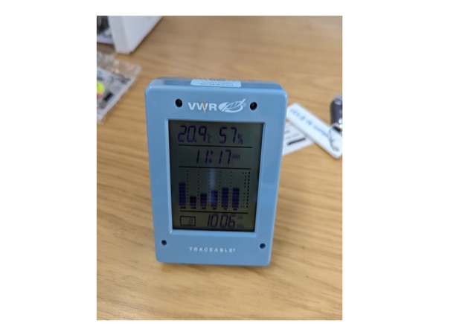
The tunnel was then set up ensuring the wall power to the tunnel was switched on and the power to the console was switched on. The data acquisition used was the VDAS Software and the aerofoil was placed in the tunnel at an angle of attack before the tunnel was run at 30% RPM (Revolutions Per Minute) by having the dial of the fan control turned until the required RPM was achieved. Figure 1.5 shows the fan control console (University of Hertfordshire, 2023)

Dynamic Pressure from the manometer was taken as the pitot tube was lowered. After recording the dynamic pressure, pitot tubes were raised to stop the interference of the flow significantly. Pressure tappings were recorded using the data acquisition application for a range of angles of attacks from 0⁰ to 15⁰ through 1⁰ increments. This was repeated for 60% RPM and 90% RPM. See figure 1.6.

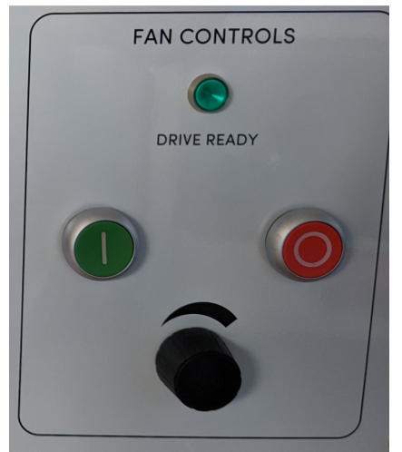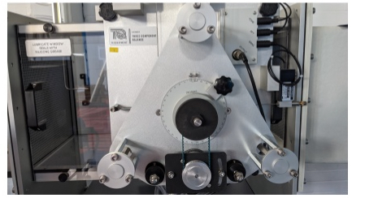

Figure 1.6 Fan Control on a Console Figure 1.7 Dial Used to Change AoA
(University of Hertfordshire, 2023) (University of Hertfordshire, 2023)

2.2Errors and Precautions

The potential sources of error came from the following.

- Change and variation in temperature as the test was being carried out.
- Parallax error in taking reading on scales.
- Conversion of units leading to different values
- Recording data too quickly before flow steadies out

Some of the precautions taken include.

- Allowing flow to become steady before taking a reading
- Zeroing out measurements apparatus before starting another test
- Ensuring there is no obstruction in front of the wind tunnel.
- Rounding off to three decimals during the conversion of units

SRN:20011451
3.CALCULATIONS AND RESULTS

Table 1.2 below shows the results recorded at local atmospheric conditions, sourced from (University of Hertfordshire, 2023). From the table, density and atmospheric pressure in Pa were calculated.

Time Taken Temperature ºC Atmospheric Pressure (mmHg)

14.05 14.0 754.5

Getting the Atmospheric Pressure in Pa simply required converting mmHg to Pascals (Pa) as shown below. The formula was obtained from (University of Hertfordshire, 2022)

$$P_{a}=(h-\frac{β-α}{1+βt}ht)x133.322$$
Where:

$$h=column height mmHg$$
$$t= temperature in C$$
$$∝=0.000185$$
$$β=0.000182$$

$P_{a}=\left( (754.5)-\frac{0.000182-0.000185}{1+0.000182(14)} (754.5)(14) \right)$x133.332

$P_{a}= 100603.208Pa$

Given we have Atmospheric Pressure in Pascals, density was able to be calculated using the equation sourced from (University of Hertfordshire, 2023) as shown below.

$$ρ=\frac{p_{o}}{1+γt} \frac{P_{a}}{P_{∞}}$$

Where:
$$P_{o}= 1.276{kgm}^{-3}$$
$$P_{∞}={10}^{5}Pa$$
$$γ=0.003661$$
$$ρ=\frac{1.276}{1+0.003661(14)} x \frac{100603.208}{{10}^{5}}$$

$$ρ=1.2211{kgm}^{-3}$$

Table 1.3 below shows a summary of the above.

Time Taken Temperature ºC Atm.Pressure(Pa) Atm.Pressure(mmHg) Density(kgm⁻³)

14.05 14.0 100603.208 754.5 1.2211

SRN:20011451
Table 1.4 shows measurement recorded from the manometer for dynamic pressure at different RPMs. (University of Hertfordshire, 2023)

Tunnel RPM (%) Manometer Reading (mmH₂O)

30 25.0

60 55.0

90 87.0

Having the data from the table above, calculating dynamic pressure and velocity was possible where,

$$P_{a}={{mmH}_{2}O}/{0.10197}$$

Where mmH₂O is the manometer reading

For example, the dynamic pressure and velocity at RPM 30% was given by,

$P_{a}={{mmH}_{2}O}/{0.10197}$ $ν=\sqrt{\frac{2q}{ρ}}$

$P_{a}=\frac{25.0}{0.10197}$ $ν=\sqrt{\frac{2(245.17)}{1.2211}}$

$P_{a}= 245.17Pascals$ $ν= 20.039m/s$

To calculate Reynolds Number Re, the equation used was,

$$Re=\frac{ρνl}{μ}$$
Where:

$$ρ=Density$$
$$v=Flow Velocity$$
$$l=Characteristic Lenght$$
$$μ=Dynamic Viscosity$$

Using Sutherland’s Law to calculate dynamic viscosity, an estimation of the dynamic viscosity was made as no actual values were given. The equation used was:

$$μ=μ_{0}\left(\frac{T_{0}+S}{T+S}\right){\left(\frac{T}{T_{0}}\right)}^{\frac{3}{2}}$$

$$μ=μ_{0}\left(\frac{T_{0}+S}{T+S}\right)\sqrt{\frac{T}{T_{0}}}$$
Where:

$$S=Surtherland^{'}s Constant depending on the fluid. For air, commonly used values are T_{0}=273.15K and S=110.4K$$

$$μ_{0}=Approxiamtely 1.846×{10}^{-5}Pa.s at T_{0}=273.15K$$
After substituting values into the formular, the estimated Dynamic Viscosity was found to be approximately 2.835 x 10⁻⁵Pa.s hence finding the Re at 30% RPM for example was given by:

$$Re=\frac{\left(1.2211\right)×(20.039)×(0.150)}{{2.835×10}^{-5}}$$

$$Re=129462$$

This was repeated for RPM 60% and RPM 90%. Table 1.5 below shows a summary of the above process.

Tunnel RPM Manometer Reading Dynamic Pressure Velocity Reynolds
(%) (mmH₂0) (Pa) (m/s) Number(Re)

30 25.0 245.17 20.039 129462

60 55.0 539.37 29.722 192029

90 87.0 853.19 37.382 241519

It was then necessary to understand and calculate lift and pressure coefficients. The equation below sourced from (University of Hertfordshire, 2023), shows how to calculate the coefficient of lift.

$$C_{L}=\int_{0}^{c}{C_{pLower}}dc-\int_{0}^{c}{C_{pUpper}dc}$$

This formula simply indicate that C_{L} is determined by integrating the pressure coefficient difference between the upper and lower surfaces of an aerofoil along the aerofoils span. The integration of chord length c indicates the consideration of the entire span of the aerofoil.

From the equation:

C_{L}= Coefficient of Lift

C_{pLower}= Coefficient of Pressure on the Lower Surface

C_{pUpper}= Coefficient of Pressure on the Upper Surface

c = Chord Length

With tappings given for the aerofoil provided, the calculation of coefficient of pressure for each tappings was given by the equation below sourced from (University of Hertfordshire, 2023).

$$C_{p}=\frac{P_{i}-P_{0}}{\frac{1}{2}ρυ^{2}}$$
Where:
C_{p}= Coefficient of Pressure

P_{i}= Tapping Pressure

P₀= Tunnel Static Pressure

$$ρ=Atmospheric Density$$

$$ν=Velocity$$

Given that we were provided with the directional positions of each tapping hole on both the upper and lower and lower surface of the aerofoil, for example, for 30% RPM tapping 1 at 0-degree angle of attack C_{p} can be calculated as
$$C_{p}=\frac{P_{i}-P_{0}}{\frac{1}{2}{ρυ}^{2}}$$

$$C_{p}=\frac{-0.43x{10}^{3}}{\frac{1}{2}(1.2211){(20.039)}^{2}}$$

$$C_{p}=-1.75$$

The table 1.6 below shows the directional positions of each tapping hole on both the upper and lower surface of the aerofoil.

Upper Surface Distance From L.E Lower Surface Distance From L.E
Tapping (mm) Tapping (mm)

1 0 2 4.78

3 3.863 4 13.84

5 12.43 6 22.99

7 21.38 8 35.22

9 33.50 10 50.50

11 48.76 12 68.53

13 67.09 14 90.20

15 88.42 16 105.46

17 109.66 18 120.72

19 127.77 20 132.94

The calculations were done at all tappings, both upper and lower surface at different angles of attack on excel and a data set of C_{P} was made from this. This enabled the plotting of coefficient of pressure against x/c graphs at different angle of attacks. x/c was obtained by dividing the distance from Leading Edge denoted by (x) at a particular tapping by the chord (c). The area under the graph was found using the equation below:
$$\sum{\frac{1}{2}×interval×(y_{2}+y_{1})}$$
Where:
$$y_{2}=coefficient of pressure at that particular tapping$$
$$y_{1}=coefficient of pressure at that particular tapping$$
$$interval=distance between tappings$$

NOTE: For intervals, the exception made is tapping 1 since distance between tappings was between tapping 1 and leading edge.

The equation denoted the trapezium rule which helped in obtaining the area under the graph by use of multiple trapeziums under the curve. Since the intervals were not constant, the area was added individually. It was important to note that the equation uses a non-dimensional chord length distance from leading edge. A calculation was carried out on both the upper and lower surfaces to find the area under the C_{p} at 0⁰ angle of attack for RPM 30% and the difference gave us the coefficient of lift C_{L}. The interval was dived by 150mm which is the chord length to make it non dimensional, for example:

Area under C_{p} graph for Upper surface

$$Area Under Graph=\sum{\frac{1}{2}×interval×(y_{2}+y_{1})}$$
=$\left({1 \atop 2}×3.863/150×(-1.75+(-2.73))+\left({1 \atop 2}×8.567/150×(-2.73+(-1.71)\right)\right)+\left({1 \atop 2}×8.95/150×(-1.71+(-1.51))\right)+\left({1 \atop 2}×12.12/150×(-1.51+(-1.31))\right)+\left({1 \atop 2}×15.26/150×(-1.31+(-1.18))\right)+\left({1 \atop 2}×18.33/150×(-1.18+(-1.14))\right)+\left({1 \atop 2}×21.33/150×(-1.14+(-1.02))\right)+\left({1 \atop 2}×21.24/150×(-1.02+(-0.78))\right)+\left({1 \atop 2}×18.11/150×(-0.78+(-0.98))\right)$

Area Under Graph= -1.05

Area and C_{p} graph for Lower Surface

$$Area Under Graph=\sum{\frac{1}{2}×interval×(y_{2}+y_{1})}$$
=$\left({1 \atop 2}×9.06/150×(-0.20+(-0.53))+\left({1 \atop 2}×9.15/150×(-0.53+(-0.69)\right)\right)+\left({1 \atop 2}×12.23/150×(-0.69+(-0.78))\right)+\left({1 \atop 2}×15.28/150×(-0.78+(-0.94))\right)+\left({1 \atop 2}×18.03/150×(-0.94+(-0.98))\right)+\left({1 \atop 2}×21.67/150×(-0.98+(-0.98))\right)+\left({1 \atop 2}×15.26/150×(-0.98+(-0.98))\right)+\left({1 \atop 2}×15.26/150×(-0.98+(-0.98))\right)+\left({1 \atop 2}×12.22/150×(-0.98+(-0.94))\right)$

Area Under Graph= -0.74

From the calculations above we can obtain the coefficient of lift using the formula

$$C_{L}=\int_{0}^{c}{C_{pLower}}dc-\int_{0}^{c}{C_{pUpper}dc}$$

$$C_{L}=-1.05-\left(-0.74\right)$$

$$C_{L}=-0.31$$

The calculations were repeated for all values at different angle of attacks and a graph of Coefficient of Lift Against Angle of Attack was plotted.

SRN:20011451

4.GRAPHS

4.1 Coefficient of Pressure Plots
The graphs below show Coefficient of Pressure Against Chord Length plotted in excel at Re 129462, 192029 and 241519 respectively.

SRN:2001145
4.2 Coefficient of Lift Plots
The graph in the left side below shows two sets of data plotted (Coefficient of Lift, Cl against Angle of Attack, AOA at Re 129462). One obtained from XFLR5 and the other from experimental values. The other graph shows The Coefficient of Lift Against Angle of Attack at Re 192029 for data obtained from XFLR5 and Experimental Values.

The Graph below shows Coefficient of Lift Against Angle of Attack at Re 238422 for Experimental
Values Data and Data from XFLR5.

SRN:20011451

5.DISCUSION OF RESULTS

5.1 Assumptions and Justification Discussion
Three assumptions were made during the lab test. These assumptions are two- dimensional flow, steady flow and incompressible flow. Since the maximum velocity of air in the wind tunnel was 37.382ms⁻¹ as shown in Table 1.5, we can calculate Mach Number using the equation:

$$Mach Number=v/c$$
Where:
$$v=velocity$$
$$c=speed of sound$$

An online calculator by the national weather service was used (National Weather Service, 2023 )to find the speed of sound at 14⁰C since the speed of sound depends on temperature, then:

$$Mach Number={37.867}/{339.61}$$

$Mach Number=$0.1

From the above results, the flow was assumed to be incompressible, and the compressibility effects of the wind tunnel can be ignored as the test was carried at relatively slow speeds which is below the critical Mach Number 0.3 for the atmospheric conditions of the test as in table 1.3. The equation below shows Bernoulli’s Equation for steady, inviscid and incompressible flow.

$$p+\frac{1}{2}ρν^{2}=constant$$
Where:
$$p=Pressure$$
$$ρ=Density$$
$$ν=Velocity$$

The above equation suggests that as the pressure reduces around the aerofoil surface, the velocity air in the boundary layer increases. The equation below (John D Anderson, 2001) shows a deeper understanding of C_{P} only for incompressible flow.

$$C_{P}+{\left(\frac{V}{V_{∞}}\right)}^{2}=1$$
Where:
$$C_{P}=Coefficient of Pressure$$
$$V=Boundary Layer Velocity$$
$$V_{∞}=Free Stream Velocity$$

5.2 Boundary Layer Formed Discussion
Formed by fluid (air) flowing along the objects surface (aerofoil), a boundary layer is a thin layer of fluid adjacent to the surface of an object and is dived into laminar and turbulent flow.
According to Bernoulli’s Principle in Fluid Dynamics, the velocity of the fluid is inversely related to pressure. This means that as the velocity of the boundary layer increases, there is a decrease in pressure along the surface of an object (aerofoil). This is evident in our case as well, since as the Coefficient of Pressure reduces, the velocity of the boundary layer increases as suggested by Re. By using the distance from the Leading Edge to the Trailing Edge as our characteristic length, the flow starts as a laminar flow over the aerofoil and as the Re increases, we end up with a turbulent flow at the trailing edge. The direct proportionality can be suggested by the following equation:
$$C_{L}=\int_{0}^{c}{C_{pLower}}dc-\int_{0}^{c}{C_{pUpper}dc}$$
If all other permeameters are to be kept constant, Re is directly proportional to characteristic length (AirShaper, 2021).

5.3 Discussion on Graphs

5.4 Discussion on Uncertainty and Error
A major source of error and inaccuracy came from calculations whilst calculating the area under the graph, the trapezium rule equation and calculating the coefficient of lift, small things such as rounding off values and how many number of decimal places to use had a big impact on the uncertainty and error.

Another source of uncertainty and error came from obtaining data for C_{L} from XFLR5 and plotting it on the same graph with data collected from the wind tunnel testing and calculations. This is because of the scaling difference between the XFLR5 graphs and experimental data graph aswell as starting point of the line in the XFLR5.

The coefficient of lift max (C_{Lmax}) from the experimental data and from data obtained from XFLR5 differed slightly. With the C_{Lmax} on XFLR 5 graph for Reynolds Number 129462 being 1 and that of the experimental data for the same Reynolds Number being 0.75. For Reynolds Number 192029, the C_{Lmax} for experimental data was 0.81 while that of XFLR5 was 1.05 and for Reynolds Number 241519, the C_{Lmax} for experimental data was 0.95 while that of XFLR5 was 1.09. Using Root-Mean-Square Deviation (RMSD) is essential to use for use to see how accurately we are. Using the RMSD Equation below sourced from (Ather, 2020), RMSD is given by:

$$RMSD= \sqrt{\frac{\sum_{1=1}^{n}{(A_{i}-F_{i})^{2}}}{n}}$$

Where:

$$A_{i}=Actual Value$$

$$F_{i}=Forecast Value$$

$$n=Total Number of Test$$

Hence, the RMSD for C_{Lmax} was:

$$RMSD= \sqrt{\frac{\sum_{1=1}^{n}{(A_{i}-F_{i})^{2}}}{n}}$$

$$RMSD=\sqrt{\frac{{(0.75-1)}^{2}+{(0.81-1.05)}^{2}+{(0.95-1.09)}^{2}}{3}}$$

$$RMSD=\sqrt{\frac{0.1397}{3}}$$

$$RMSD=0.2$$

From (Mendoza, 2019), an RMSD of 0.2 indicates that despite the errors, the data obtained from the test was relatively accurate hence can be useful in the design process.

SRN:20011451

6.CONCLUSION

With the equation below sourced from (University of Hertfordshire, 2023), the C_{L} data on this report can help researchers and engineers specialising in aerofoils, wings and aerodynamics to determine the amount of lift their design would generate helping them make the right choices and decisions on their design. The equation is:

$$Lift=\frac{1}{2}{ρν}^{2}C_{L}A$$

Where:

$$A=Wing Platform Area$$

$$C_{L}=Coefficient of Lift$$

$$ρ=Atmospheric Density$$

$$ν=Velocity$$

From this data, Bernoulli’s Principle on lift generation where lift is produced due to the pressure difference on the upper and lower surface of an aerofoil is evident. The use of RMSD suggests that the values were accurate enough and the report shows that wind tunnel testing is a crucial part for researchers and engineers in designing of wings for commercial planes or private. Depending also on the problem being solved, carrying out wind tunnel testing is essential to understand a lot of things such as where structures need to be stronger or what where to put the pay load.

SRN:20011451

7.REFERNCE

AirShaper, 2021. What is a Boundary Layer - Laminar and Turbulent boundary layers explained. s.l.:s.n.

John D. Anderson, J., 2001. Incompressible Flow in a Duct: The Venturi and Low-Speed Wind Tunnel. In: Fundamentals of Aerodynamics. 3rd ed. New York: McGraw-Hill,pp.184-202

National Weather Service 2023. Speed of Sound Calculator, [23 November 2023], Available at: Available at: https://www.weather.gov/epz/wxcalc_speedofsound.

Veludurthi, Ajay & Bolleddu, Venkateshwarlu. (2020). Experimental Study on Modal and Harmonic Analysis of Small Wind Turbine Blades Using NACA 63-415 Aerofoil Cross-Section. Energy Engineering. 117. 49-61. 10.32604/EE.2020.010666.

Nancy Hall 2022, Bernoulli and Newton, National Aeronautics and Space Administration (NASA), [ 20 November 2023], Available at: https://www1.grc.nasa.gov/beginners-guide-to-aeronautics/bernoulli-and-newton/#:~:text=Arguments%20of%20Theories,deflecting%20a%20flow%20of%20gas.

University of Hertfordshire 2023, Aerodynamics Lab Instruction Sheet, [18 November 2023], Available at: https://herts.instructure.com/courses/105894/assignments/234482.

Anderson, J 2016, Fundamentals of Aerodynamics, McGraw-Hill Higher Education, NY. Available from: ProQuest Ebook Central. [18 November 2023]

Ather, S. H. 2020, How to Calculate RMSD, Sciencing, [25 November 2023], Available at: https://sciencing.com/calculate-rmsd-5146965.

Mendoza, R. M. O 2019, What’s the acceptable value of Root Mean Square Error (RMSE), Sum of Squares due to error (SSE) and Adjusted R-square. s.l.:s.n.

John D. Anderson, J. 2001. Pressure coefficient. In: Fundamentals of Aerodynamics. 3rd ed. New York: McGraw-Hill, pp. 203-204

John D. Anderson, J., 2001. The Kutta Condition. In: Fundamentals of Aerodynamics. 3rd ed. New York: McGraw-Hill, pp. 290-295

John D. Anderson, J., 2001. The Kutta-Joukowski Theorem and the Generation of Lift. In: Fundamentals of Aerodynamics. New York: McGraw-Hill, pp. 244-247

8.APPENDIX

Appendix I: value of P_{i} – P_{o} for each tapping at different Angle of Attacks and Re for tappings 1-20 copied from excel worksheet.

SRN:20011451

Appendix II: value of Coefficient of Pressure C_{p} for each tapping at different Angle of Attacks and Re for tappings 1-20 copied from excel worksheet.

SRN:20011451

